**Progress Report II**

**On**

**ParkMeRight**

**Submitted By**

**Monika Sharma**

**Tarun Dhiraj**

**Under the guidance of**

**Prof. DiptiTheng**

**Department of CSE**

**Department of Computer Science & Engineering**



**Department of Computer Science & Engineering**

**G. H. Raisoni College of Engineering**

**Digdoh Hills, Nagpur**

**Session 2013-2014**

**INDEX**

* WEB APPLICATION
  + Login Page
  + Forgot Password
  + Personal Information
  + Terms and conditions
  + Main page
* ANDROID APPLICATION
  + Login Page
  + Sign Up page
  + Forgot Password
* PHASE TO BE COMPLETED IN PHASE III

**WEB APPLICATION**

**Login Page:**

The web app starts with the login page where the user has to enter the username or email id provided to them and the password which will allow them to access their unique and respective accounts.

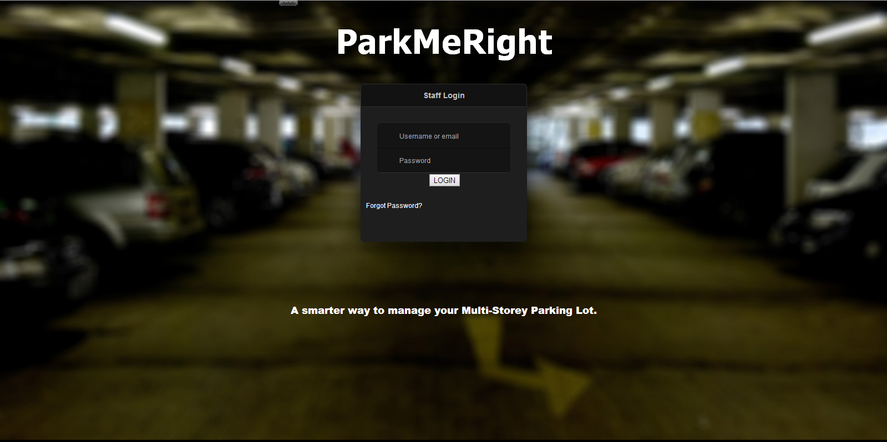

Fig 1: Login Page

**Forgot Password:**

If the user in any case forgets the password to access the account, they can click on the forgot password link. They would be directed to a page asking their email id which was registered with the organisation and the new password would be sent to that email id of user as shown in fig 2.a and 2.b.

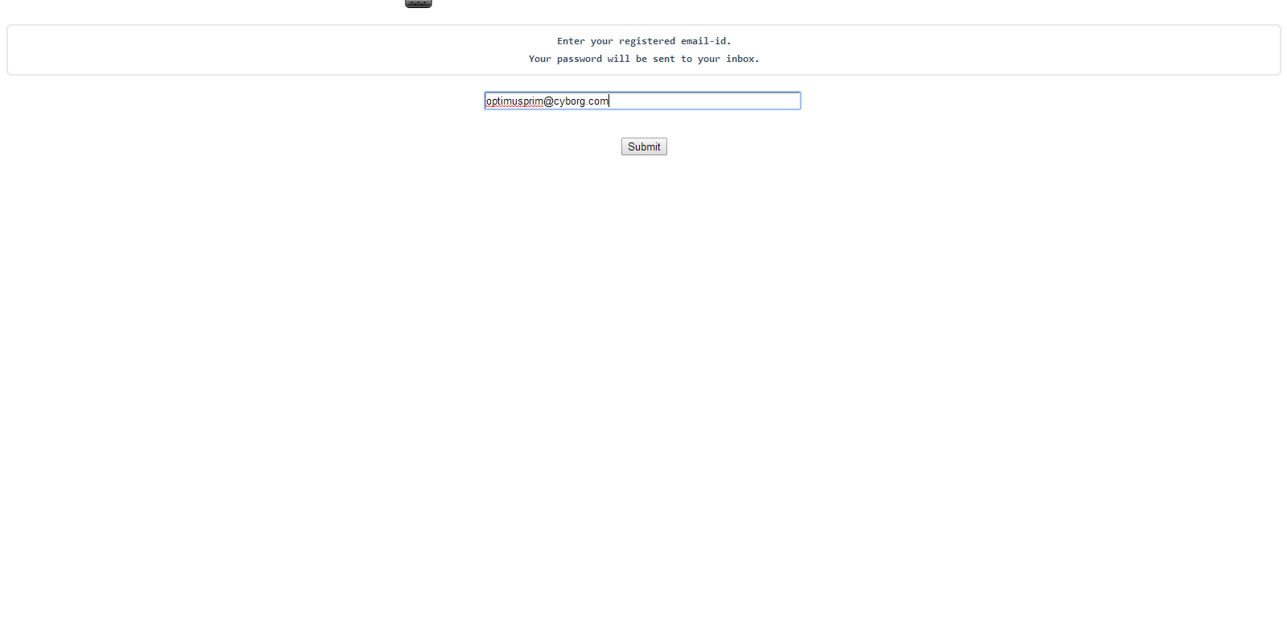

Fig 2.a: Password Help

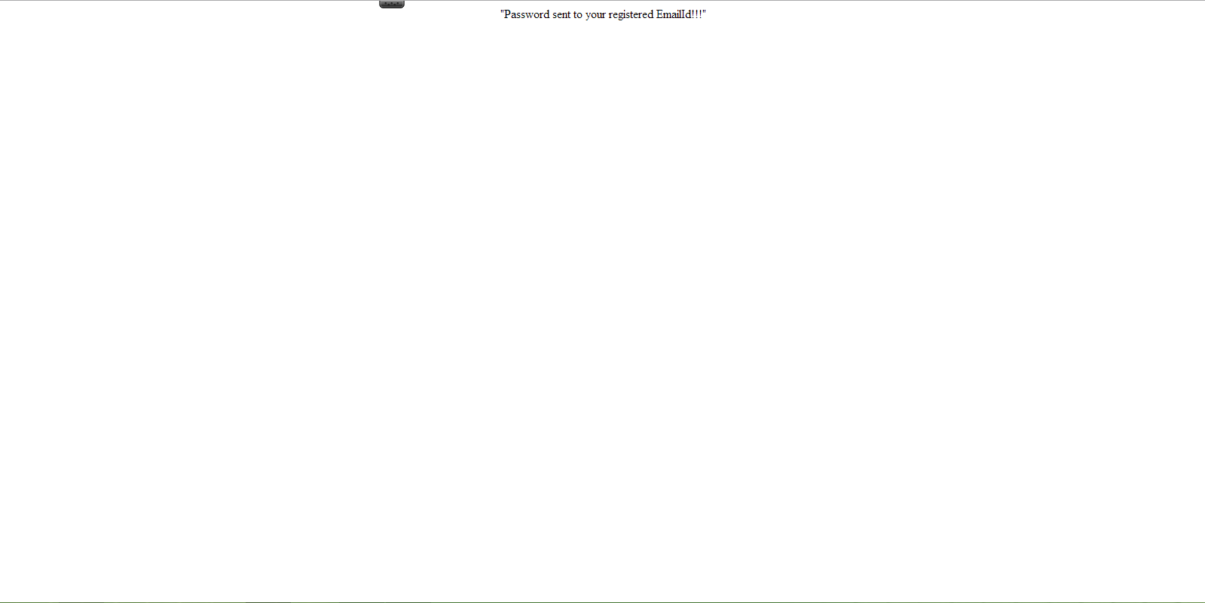

Fig 2.b: Password Help

**Personal Information:**

The person using Web App for the first time would have to fill some mandatory information in order to proceed further. Without filling this form, they would not be allowed to access their account. Except for the first time, the user would directly get the access to their account and they can carry on with their work.

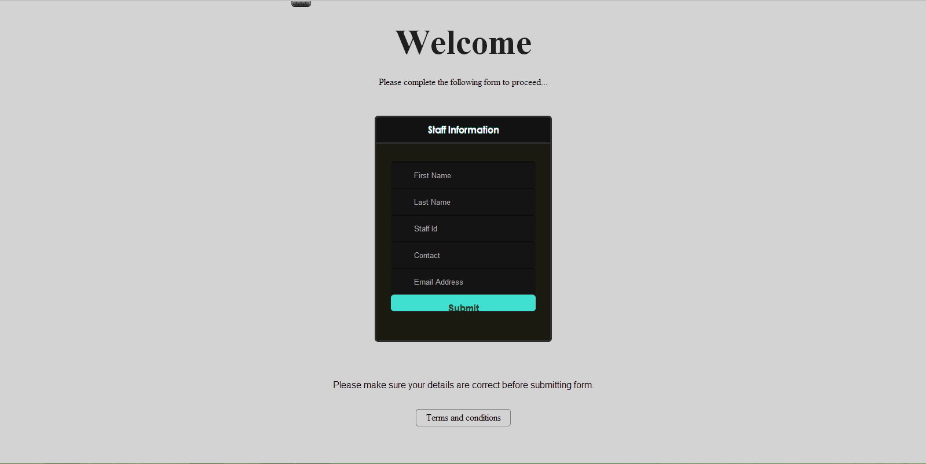

Fig 2: Form to be filled out by first time Users

**Terms and conditions:**

By filling this information and clicking on submit would mean that the user agrees to the terms and conditions of the organisation and thereafter they cannot disagree with any of the organisation’s demands. The user can see the terms and conditions by clicking on the corresponding link.

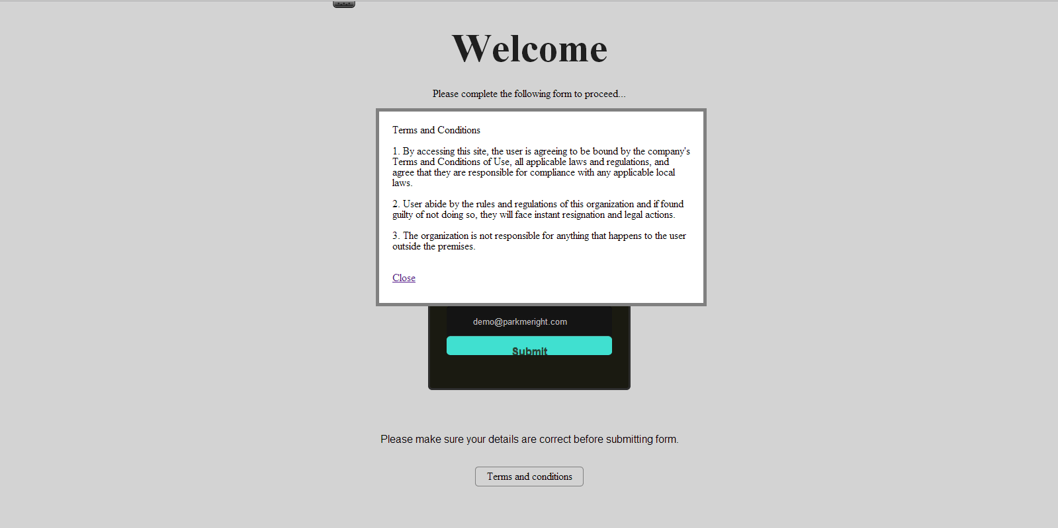

Fig 3: Terms and conditions

**Main page:**

After submitting the form, the user would get the access to their account and they can see the booking status of the parking slot floor and slot-wise. On the left hand side, they can choose a slot from the available ones at the time of on-spot booking while on the right hand side they have to fill in the details of the customer. The booked slot would be shown in red where as it would be shown as grey if available or pre-booked.

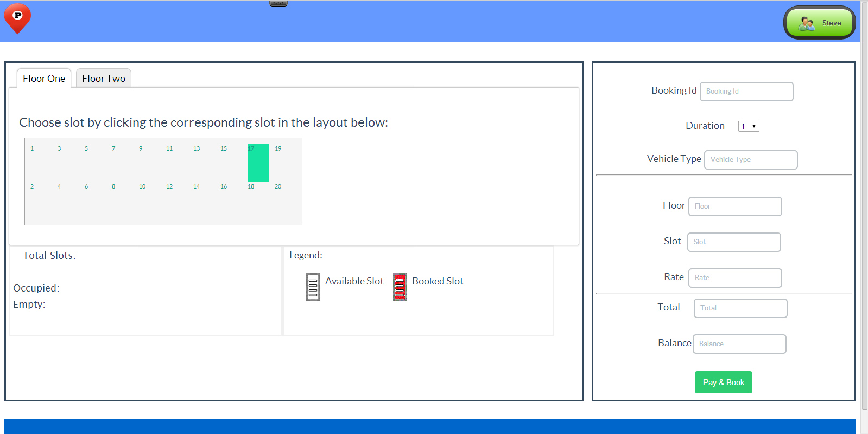

Fig 4: Home Page of User

On the right hand top-most corner the username is visible clicking on which would provide three options as shown in fig 5:

1. Home: It would take the user to the main page of their account.
2. Profile: This option takes the user to the profile page of their account and shows all the information submitted by them as shown in fig 6.
3. Logout: By clicking on this option user can get logged out of their account.

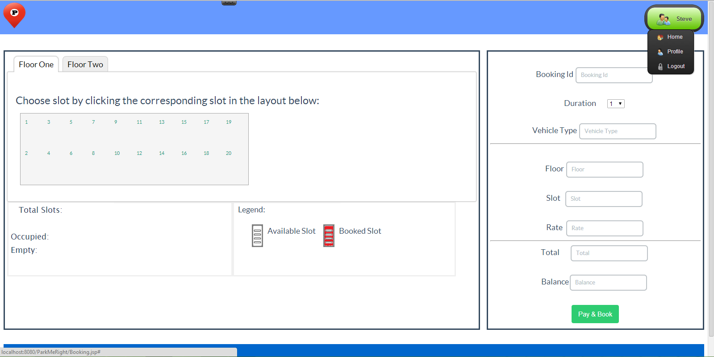

Fig 5: Three Options to Users

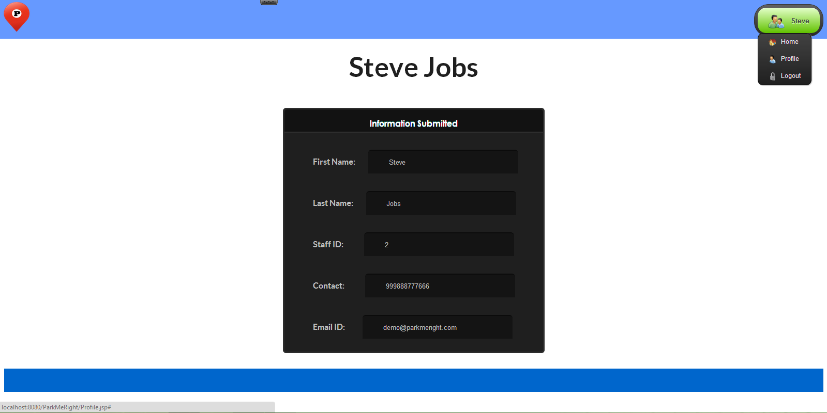

Fig 6: Profile Page of User

**ANDROID APPLICATION**

**User Login:**

The android user, who wants to pre-book the parking slot in the multistorey parking organisation, has to do so through an account registered with that particular organisation. The user has to login into their account using the email ID and password.

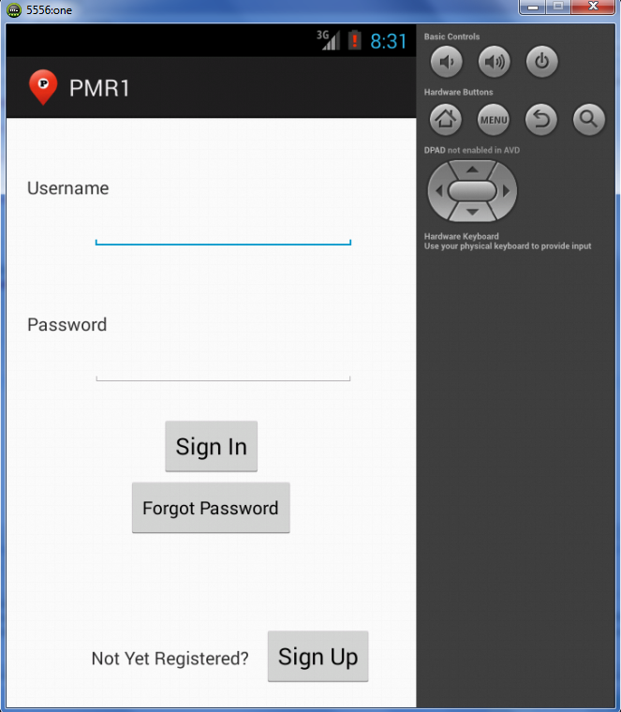

Fig 7: Login Of Android User

**Sign Up:**

If the user is not registered yet or does not have an account then they can do so by signing up with the organisation. They just have to provide some personal information and click on register as shown in fig 8.

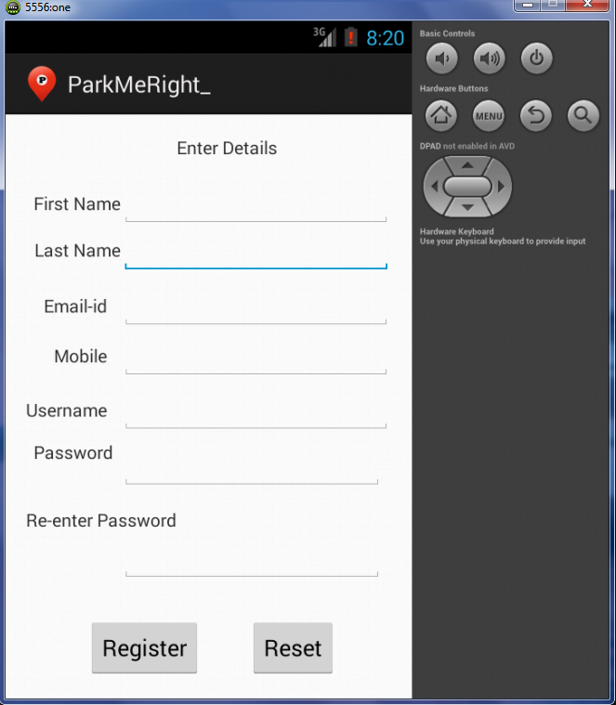

Fig 8: Sign up of User

**Forgot Password:**

In case the user forgets the password, they can click on the link provided at the main login page and provide their registered Email ID. The password would be sent to the user on this mail ID.

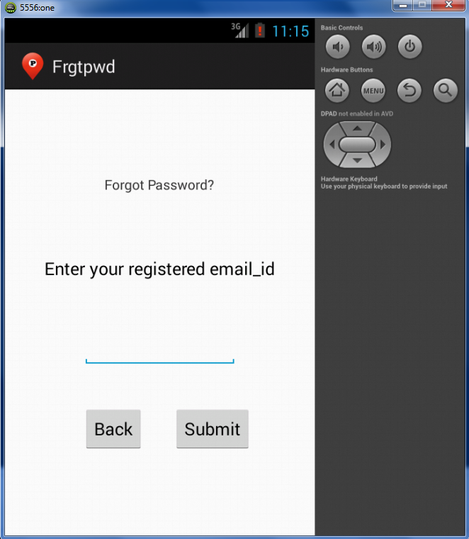

Fig 9: Forgot Password

**Work To Be Completed in Phase III:**

The project team would work to achieve the following milestones in next phase:

1. The android app will function correspondingly.
2. The android app would be connected to the web app.